International Slalom Skateboard Racing Rules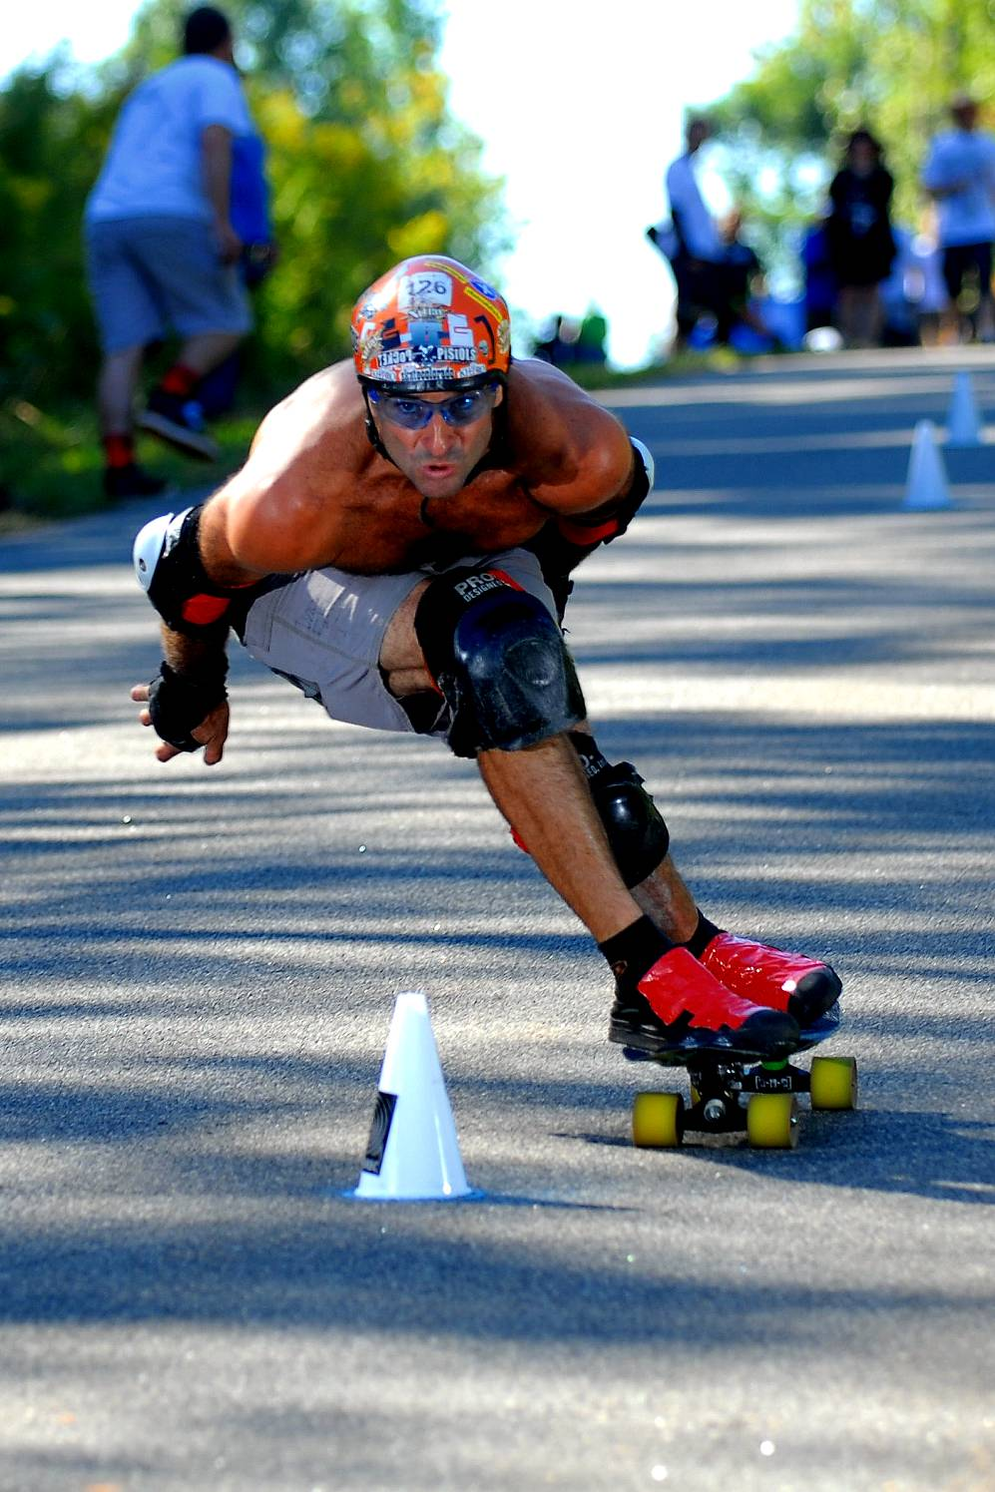
Photo: Farid A. Abraham
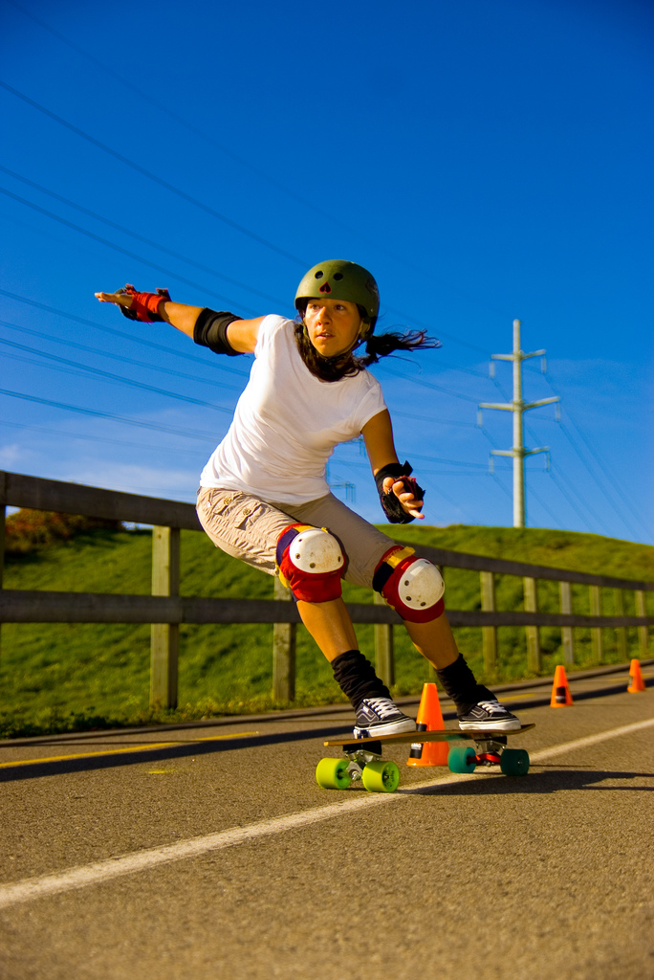
Photo: Boris Firquet

Copyright 2007 ISSA www.slalomskateboarder.com
ISSA Slalom SkateboardING Rules

Revision History
Revision | Name | Date | Description
1.1 | ISSA Board of Directors | 18DEC2007 | Approved rules

Introduction
These are the ISSA Slalom Skateboarding Rules. The objectives of these rules are to:
- Provide contest directors and racers with a uniform set of written rules.
- Allow some variation for contest directors to customize events to suit their tastes.
- Allow for a method to change these rules in the future.

A slalom skateboard race consists of a prescribed course set out on a hard surface, marked with cones. The skateboard racer passes through the course, alternately passing the cones on the left and right. The racer is timed through the course. Time penalties are assessed if the racer fails to complete the course or displaces cones in the course.

These rules are in effect for the calendar year 2008

These rules will be updated in 2008. Members of the ISSA may propose rules changes at any time before September 1 2008. The rules committee of the ISSA may then accept, modify, or reject the proposed rule change for the 2009 rules.

The ISSA Board of Directors may make clarifications, emergency changes, or alterations to these rules during the race season by a majority vote of the Board of Directors.

Equipment

Required Equipment
- Protective Equipment
- Helmet: No restrictions on type or design.
- Shoes: One shoe must be worn on each foot.
- Optional Protective Equipment: Knee pads, elbow pads, gloves, etc.
- Skateboard
- Deck: The deck must be structurally sound and not pose a safety hazard. It may be any shape, size, or construction.
- Wheels: Exactly 4 wheels. No other restrictions.
- Trucks: No restrictions on number. The trucks must be lean steer activated.
- Competitors are required to ride in a standing (upright) position.

Prohibited Equipment
- Propulsion devices or mechanisms
- Brakes, clutches or other devices providing torque to the wheels.
- Bindings, toe straps, or other devices attaching the shoes to the deck.
- Aerodynamic fairings, parachutes, sails, or other such devices.
- Handles, seats, supports, or other equipment that provides an interface from the racer to the board other than the sole of the shoe.
- Equipment that is consumed, discarded, or jettisoned during the race.
- Steering mechanisms activated by means other than lean-to-steer.

Allowed Equipment (including, but not limited to)
- Foot stops or other devices to limit the lateral movement of the feet on the deck. They must not wrap over, trap, or affix the rider’s foot to the deck in any way.
- Concave, kick-tail, camber, and other shape modifications to the flat deck.

Slalom Race Description

Single-Lane
Single-lane slalom races are run 1-racer at a time. Two runs are made by each racer. The final placing of the racers is determined by taking the single best time from each racer.

Dual-Lane
Dual-lane slalom races consist of two identical (either parallel or mirrored) courses. Two racers run at the same time. The race is split into a Qualifying round and a Head-to-Head round.
- Qualifying: The racers take one run on each course.
- The qualifying position is determined by taking the single best time from either course.
- Head-to-Head racing: The racers are seeded into brackets and take one run in each course, with their opponent in the other course.
- The winner of the round is determined by taking the sum of both runs.
- The loser of the round is eliminated from further competition.
- Rounds are taken until the final 2 racers face off for the 1st place round.

Start
The start consists of a starting platform (ramp) elevated above the surface of the course. The racer stands on the start platform with his feet on the skateboard and upon signal from the race official, propels down the platform and onto the race course. A signaling device determines when the racer has started.

Cones and Course
Cones are placed on the course surface to indicate the turn points for the racer. The cones shall be negotiated in left/right sequence down the course. Cone spacing and placement depends on the type of course (see Section 9). The object of the race is to successfully pass each turn point in the fastest time.
The course direction at the 1st cone shall be marked to indicate the entry direction into the course.
Once the course is set, the course officials shall mark a cone-circle around each cone to determine placement of the cones after each run, and to determine cone displacements during a run.
Cone specification:
- Base diameter: 140 mm +/- 20mm
- Cone height: 230mm +/- 30mm
- Material: Plastic
- Construction: Hollow (light weight)
- Base Flange: Not allowed
- No openings in side-wall of cone.

Finish
The finish consists of a line perpendicular to the course and no closer than 2m from the final cone. The finish shall provide a signal to the timing equipment to stop the timing when the racer passes the finish line.

Race Runs

Start of Run
The start of the run shall follow a predictable and consistent sequence for all racers:
- Racers are called to the start and assume a ready position in the start ramp
- Race officials determine that the course is ready and the racers are ready.
- The timing system is armed and the racers given an audible signal.
- The timing system provides tones on 1-second intervals:
- 3 seconds to start
- 2 seconds to start
- 1 second to start
- START (Shall differ in pitch, duration, or volume from the preceding tones)
- Upon START signal, the clock will start for both courses, regardless of whether the racers have passed the start line.
- Should a racer start before the START signal, the racer shall be penalized by an amount of 2X the early-start interval.
- Should a racer start after the START signal, no additional penalty is given.

Successful Passing Through The Course
A racer is deemed to have successfully passed through the course if the skateboard:
- Passes thru the start line and triggers the start signal.
- Passes cones on the correct side.
- Passes cones on the incorrect side, yet displaces the cone.
- Passes through the finish line and triggers the finish signal.
- The racer is not disqualified for other reasons.

Cone Displacements
A cone is counted as being displaced if either of these occurs:
- The entire base of the cone is outside of the entire cone-circle on the surface of the course.
- The cone is tipped over and not standing upright.

A cone is NOT counted as being displaced if:
- The cone is tipped over by an outside agent (includes being hit by a cone from the adjacent course).

The cone penalty shall be:
- 0.1 second for Slalom races
- 0.2 second for GS races
- 0.3 second for Super-GS races

Disqualifications
The racer is disqualified during the run for any of the following:
- Unsuccessfully passing through the course.
- Displacing more than 20% of the cones. (20% + 1 cone is a DQ)
- Displacing any cone by contact above the knees.
- Placing any part of the body (including hands and feet) onto the course surface during the race.
- Unsporting conduct (interfering with a racer, damaging equipment, etc.)

Finish of Run
The time for each racer stops when the racer passes over the finish line.
After passing the finish line, the racer may stop in any manner (foot-drag, slide, carve, turn uphill, etc.)

Calculation of Time

Calculating the Resulting Time
The time for each racer is calculated by the formula:
RT = ET + SP + (CD*CP)
Where:
- RT is the Resulting (final) Time
- ET is the Elapsed Time from the START tone to the racer’s finish
- SP is the Start Penalty for starting early
- CD is the # of Cones Displaced
- CP is the Cone Penalty for this race

Penalty for Disqualifications
The racer’s Resultant Time (RT) is set at 999 seconds if the racer is disqualified during runs in single-lane competition or in qualifying.
When a single racer is disqualified during Head-to-Head racing, the racer receives a Resultant Time (RT) of 1.5seconds added to the other racer’s Resultant Time (RT).

Provisions for Ties
If racers should be tied during a race, the following shall apply in the order given:
- During qualification runs
- The racer’s slower run of the 2 runs are compared to break the tie.
- The racer with the lowest cone count shall be the winner of the tie-breaker.
- The racers who are still tied are placed into the head-to-head seeding in random order among the tied racers.
- During single-lane competition:
- The racer’s slower run of the 2 runs are compared to break the tie.
- The racer with the lowest cone count shall be the winner of the tie-breaker.
- If that does not break the tie, then the racers are tied in the final placement.
- During head-to-head competition:
- The racer’s fastest run of the 2 runs are compared to break the tie.
- The racer with the lowest cone count shall be the winner of the tie-breaker.
- The racer with the higher placement in the qualifying round shall be declared the winner of the head-to-head round.

Head-to-Head Brackets

Size of Brackets
Racing brackets shall be formulated as follows. The Qualifying Group size is determined after the qualifying runs have been made, eliminating all racers who did not receive a qualifying time (after DQ on both runs):
Qualifying group equal or greater than | Qualifying group Less than or equal to | Head-to-Head Bracket size
3 | 9 | 4
10 | 19 | 8
20 | 29 | 16
30 | 59 | 24
60 | ------ | 32

Seeding of Brackets
The racing bracket shall be constructed by placing the qualifying racers into the qualifying positions indicated.

32-group | 24-group | 16-group | 8-group | 4-group
1 | 1 | 1 | 1 | 1
32 | BYE
16 | 16 | 16
17 | 17
8 | 8 | 8 | 8
25 | BYE
9 | 9 | 9
24 | 24
4 | 4 | 4 | 4 | 4
29 | BYE
13 | 13 | 13
20 | 20
5 | 5 | 5 | 5
28 | BYE
12 | 12 | 12
21 | 21 |  |  |  | FINALS FOR 1st, 2nd
2 | 2 | 2 | 2 | 2 | CONSOLATION for 3rd, 4th
31 | BYE
15 | 15 | 15
18 | 18
7 | 7 | 7 | 7
26 | BYE
10 | 10 | 10
23 | 23
3 | 3 | 3 | 3 | 3
30 | BYE
14 | 14 | 14
19 | 19
6 | 6 | 6 | 6
27 | BYE
11 | 11 | 11
22 | 22

When the racing gets to the final 4:
- 1v4 and 2v3
- Losers proceed to the “consolation” (3rd and 4th place) bracket
- Winner proceed to the “championship” (1st and 2nd place) bracket

Final Placement of Racers
Final placement of the racers in head-to-head competition is as follows:
- Those racers who did not receive a qualifying time due to DQ on both runs shall share last place.
- Those racers whose qualifying time does not place them into the head-to-head brackets receive a final placement equal to their qualifying placement.
- Those racers eliminated in the group of 32 will receive places 17-32 in order of their qualifying placement.
- Those racers eliminated in the group of 16 will receive places 9-16 in order of their qualifying placement.
- Those racers eliminated in the group of 8 will receive places 5-8 in order of their qualifying placement.
- Winner of the consolation round receives 3rd place, loser receives 4th place.
- Winner of the championship round receives 1st place, loser receives 2nd place.

Special Situations and Exceptions

Re-Runs

Situations leading to a Re-Run
A Re-Run may be granted in the following cases:
- The timing equipment malfunctions.
- The start ramp is displaced or damaged.
- The course is not set properly with each cone within the circle.
- The racer is interfered with by an outside agent (people on course, animals, wind blowing cones, soccer ball on course, etc.)
- The racer must abandon the course and immediately ask for a Re-Run.

Situations not leading to a Re-Run
- A cone from the adjacent course interferes with the racer.
- A cone from the racer’s course interferes with the racer.
- The racer’s own skateboard, pads, clothing, or other equipment fails.
- The racer does not immediately abandon the course and ask for a Re-Run.

Re-Run Procedure
- For single-lane courses, or during the Qualifying rounds.
- The racer receives a Re-Run at a time determined by the race officials.

- For Head-to-Head competition within the bracket rounds:
- The racer’s opponent is informed and may elect to also take a Re-Run.
- If the opponent does not elect to take a Re-Run, his results from the previous run stand as-is.
- If the opponent is taking a Re-Run, both racers take the Re-Run at the same time.
- The Re-Run must be completed before the current round is complete.

- The original run results are discarded and the Re-Run results are recorded.

Abandonment of Race
If the race should be abandoned by the race officials, the following shall apply to determine the final placing of the racers:
- During Qualifying or Single-Lane Racing:
- If the entire field of racers has not completed their 1st run, the race is declared void and no final results posted.
- If the entire field of racers has completed their 1st run and the race is abandoned during the 2nd run, then only the results of the 1st run shall be used to determine the placing.
- During Head-to-Head Racing:
- Racers not entering the head-to-head rounds receive results as usual, based on the completed qualifying round.
- Racers eliminated during complete rounds receive placing as usual.
- Racers currently competing in an abandoned round (both runs have not been completed) will receive the remaining placing based on their qualifying times.

Protests
Protests are only allowed in the higher status competitions (MAJOR, MAIN). Protests are not allowed in the lower status competitions (PRIME, BASIC, PLAIN). The procedure is:
- Race officials provide protest forms for the racer to fill in.
- Racer fills in a protest form.
- Within 10 minutes of the end of the current round (Qualifying, group of 32, etc)
- Racer states which rule was not followed and gives statements or evidence on the form.
- Race officials form a Protest Jury consisting of
- Head Race Judge
- Racer Jury Member (should be selected before race starts)
- One person chosen in agreement by the Racer Jury Member and the Head Race Judge.
- Protest Jury reviews the written protest form, may ask for witnesses, and may talk to the affected racer(s).
- Protest Jury renders a final verdict with one of the following outcomes
- The racer is allowed a re-run (subject to the rules on Re-Runs)
- The racer’s cone count or DQ status is adjusted based on the evidence.
- No changes in results are made.
- The decision of the Protest Jury is final and cannot be re-protested.
- A racer is only allowed one protest per race.
- A racer may only submit a protest for actions where the racer was involved.

Course Technical Specifications

Timing System
Timing Systems on the ISSA-approved list shall be used.

Starting Ramp
Start platforms shall:
- Be a minimum of 0.75m tall.
- Be a maximum of 2m tall
- Be a maximum angle of 45 degrees from horizontal
- Contain transitions of minimum radius 1m
- Be placed no closer than 4m from the 1st cone in the course.
- Provide hand-holds for the racer to pull on for propulsion from the start
- Have a signaling device placed such that the timing equipment can be signaled when the racer starts from the ramp.

Straight Parallel Slalom (SPS)
- Course Intent: Test the racer’s ability to turn as quickly as possible on a regular, straight line course down the fall line of the racing surface. Turns are all short radius.
- May be run on flat or sloped surfaces.
- Cone Spacing Limits: 1.0m to 3.0m
- Cone Spacing Suggestion: 1.5m to 2.0m
- Course Length: 25 to 100 cones. (Suggestion: 50 cones)

Tight Slalom (TS)
- Course Intent: Test the racer’s ability to turn very quickly, with occasional rhythm interruptions and offsets away from the fall line. Course is primarily down the fall line of the racing surface. Turns are all short radius.
- May be run on flat or sloped surfaces.
- Cone Spacing Limits: 1.4m to 3.0m
- Cone Spacing Suggestion: 1.5m to 2.5m
- Course Length: 25 to 100 cones. (Suggestion: 50 cones)

Hybrid Slalom (HS) [also known as Slalom: Special (SS)]
- Course Intent: Test the racer’s ability to turn quickly, with constantly-changing interruptions and offsets away from the fall line. Course may combine fall-line sections, angled sections, and curved sections. Turns are a mixture of short-radius and medium-radius.
- Sloped surfaces of moderate pitch are used. (Suggestion 3% to 8% grade.)
- Cone Spacing Limits: 1.5m to 4.5m
- Cone Spacing Suggestion: 2.0m to 3.0m
- Course Length: 25 to 100 cones (Suggestion: 50 cones)

Giant Slalom (GS)
- Course Intent: Test the racer’s ability to make a variety of short, medium, and long-radius turns through the course. The course should use the full width of the racing surface, with the course curving a smooth path down the hill. May be run single-lane or dual, depending on road width. Speeds are higher than the Slalom events. Racers tuck occasionally for short intervals.
- Sloped surfaces of moderately-steep pitch are used. (Suggestion 3% to 10% grade.)
- Cone Spacing Limits: 2.0m to 10m
- Cone Spacing Suggestion: 3.0m to 5.0m
- Course Length: 20 to 100 cones. (Suggestion: 40 cones)

Super-GS (SGS)
- Course Intent: Test the racer’s ability to make high-speed long-radius turns through the course. The course should use the full width of the racing surface, with the course curving a smooth path down the hill. Speeds are much higher than the Slalom events. Racers turn while tucking for whole subsections of the course. The cones shall determine the turning points, not just the curves in the road (to distinguish from downhill racing).
- Sloped surfaces of moderately-steep pitch are used. The road follows several natural curves and changes of pitch. (Suggestion 3% to 10% overall grade.)
- Cone Spacing Limits: 3.0m to 20m
- Cone Spacing Suggestion: 5m to 15m
- Course Length: 20 to 100 cones. (Suggestion: 40 cones)

Course Setting
The race organizer is responsible for setting the course. The method used shall be clearly stated in the race sanction application. (Who will set the course, description of course, when will course be set, etc.)

Racer Classifications, Racer Groupings, Awards, AND Overall Winner

Racer Classifications
The following racer classifications are recognized. Not every contest will award points, prizes, and medals to every one of these classifications. A racer must race in one and only one classification for each race.
- Open: Every racer may race in the “open” classification.
- Skill level (self declared grouping):
  - Pro / Amateur
- Gender
  - Female / Male
- Age:
  - Juniors: (17 and under) racers who’s age will not reach 18 in the current year.
  - Teens: (14 and under) those racers who’s age will not reach 15 in the current year.
  - Kids: (11 and under) those racers who’s age will not reach 12 in the current year.
  - Masters: Those racers who’s age is 45 years or older.

Racer Groupings
The race organizer will decide which racer classifications will be run independently, and which ones grouped together under the “open” classification. It is suggested that racer groupings only be implemented if there are more than 8 racers in the group. The race organizer may choose to use different courses for different racer groups. (e.g. A less challenging “Kids” race.) Groupings can use the logical combinations of racer classifications above (e.g. Amateur-Female-Kids group).

Prizes and awards
Award of prizes, points, and other items may be made into the various Racer Classifications even if the race is not separately grouped in that manner. (e.g. Giving the top Female finishers an award in a race with all racers in a single “Open” grouping.)

Overall Winner
An event with several races may give awards for the overall winner. The method of calculating the overall winner shall be:
- Racers may enter as many events as desired.
- One event is declared the “tie breaker” before the competition begins.
- Racers receive points in each race according to the chart. (Below)
- Racers are sorted from highest to lowest sum of total points over all events.
- Ties are broken by comparing racer placing in the “tie breaking” event.
1st place = 100 | 7th place = 36 | 13th place = 20 | 19th place = 12 | 25th place = 6
2nd place = 80 | 8th place = 32 | 14th place = 18 | 20th place = 11 | 26th place = 5
3rd place = 60 | 9th place = 29 | 15th place = 16 | 21st place = 10 | 27th place = 4
4th place = 50 | 10th place = 26 | 16th place = 15 | 22nd place = 9 | 28th place = 3
5th place = 45 | 11th place = 24 | 17th place = 14 | 23rd place = 8 | 29th place = 2
6th place = 40 | 12th place = 22 | 18th place = 13 | 24th place = 7 | 30th place = 1
31st place =0; 32nd place = -1 ; 33rd place = -2 ; Points decrement by 1pt per place

Contest Director Instructions

Course Officials
- Required Course Officials
- Head Race Judge – Makes on-the-hill decisions and is head of the Protest Jury
- Suggested Course Officials
- Head Timer – Runs timing equipment and records the final cone-counts.
- Head Cone Judge – Coordinates cone judges and informs Timer of the final cone count and DQ’s for each racer.
- Other possible Course Officials
- Cone Judges – Count displaced cones, determine if racer has negotiated the course correctly.

It should be made clear to all racers which people are acting as course officials, and which are merely doing clerical, voluntary, or manual-labor functions. It is suggested that the Course Officials wear some sort of identifying clothing (special shirt, hat, vest, etc).

Allowable Variations from Rules
Variations from these rules are allowable under the following conditions:
- For MAJOR and MAIN status competitions:
- Variations shall be stated clearly in the contest sanction application.
- Variations shall be declared in written communication to the racers on the day of the race.
- Variations shall be minor, few, and not significantly change the nature of the race.
- Examples of possible variations: Start ramp specification variation (larger, smaller, etc); Tone count-down variation.

- For PRIME, BASIC, PLAIN status competitions:
- Variations shall be stated clearly in the contest sanction application.
- Variations shall be declared to the racers on the day of the race (e.g. in a Racer’s meeting or announcement).
- Variations are allowed to alter the nature of the race.
- Examples of possible variations: Push-start vs. ramp start; A-B-C bracketing system to expand the # of racers entering head-to-head rounds, taking 4 runs on a single-lane race instead of 2 runs.

- ISSA Regional Contest Coordinators will review contest sanction applications and may reduce the contest status based on the number and magnitude of the declared variations from these rules.
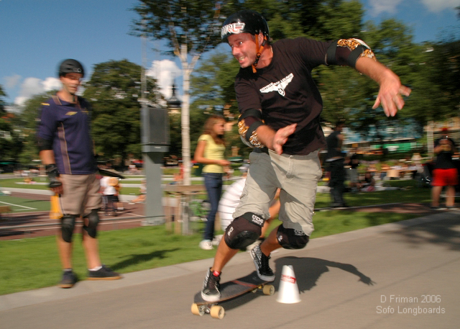

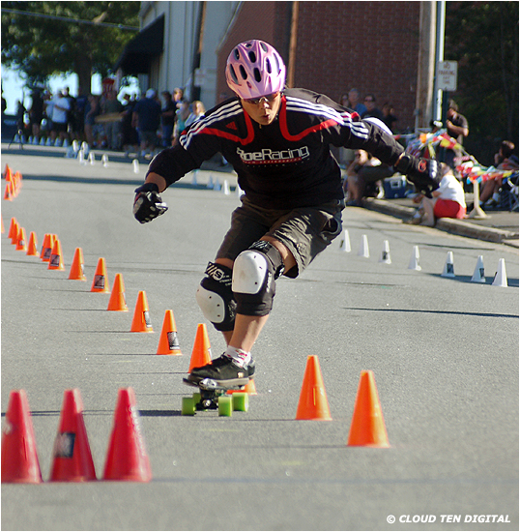
- 
Photo: Boris Firquet

