Skateboard Timing System

Overview
A timing system is used to measure the time it takes for skateboarders to complete a slalom course. The typical skateboard contest has two courses, with two racers competing simultaneously in dual side-by-side courses. The courses are 200ft to 800ft long.

Usage Model
- The timing system is armed and prepared for start.
- The official starter ensures that the racers are ready, the course is clear, and the system ready to time the racers.
- The racers are given a count-down to start.
- The race official presses the “GO” button. The timing equipment emits a “beep” and the two parallel timing systems start timing the runs.
- When a racer finishes the course, his time is stopped and displayed.
- When the 2nd racer finishes the course, his time is stopped and displayed.
- The times are recorded. (manually)
- The timing equipment is reset to zero, and armed for the next race.

Operating Modes
Two distinct operating modes are employed:
- MODE A: Race-official initiates “START” of both clocks simultaneously. (The START button starts both clocks at once.)
- MODE B: Racers initiate their individual “STARTS” when they move from the starting position. (A start sensor is used on each course.) The START button can be used as an audible signal to the racers, but is not used to actually start the timing equipment.

Design Parameters
- Distance from START to FINISH : 100 feet to 1000 feet
- Number of courses: Two (Red lane, White lane)
- Display precision: .01 s
- Min/Max time: 0:04.99 to 9:59.99
- Sensors:
  - START, MODE A: A momentary push button operated by the race official
  - START, MODE B: Two momentary switches, one operated by each racer. (This is usually a mechanically operated SPST momentary switch. It could be a wand switch, a tape switch, or a mechanical gate connected to a switch).
  - FINISH: Finish switches can be either tape switches or electric-eye switches.
  - RESET: a reset switch on the face of the unit
- Beeper: A beeper emits a sound whenever the START button is pressed.
- Connectors for external cables to sensors and devices
  - Wires to START switches for Red course and White course.
  - Wires to FINISH switches for Red course and White course.
- Power: Battery powered with AA batteries.

Problems/Challenges
- Low-cost
- Design of the two modes of operation.
- Ruggedness
- START and STOP sensors will usually give multiple triggers which must be “ignored” for some time to prevent the timing system from false start/stop signals. These multiple triggers are caused by:
  - Switch bounce
  - Multiple wheels going over tape switches at start and finish lines
  - Mechanical vibration in the wand or gate mechanism.

Suggested Approach
- Off-the-shelf stop watches are disassembled and used for the basic timepieces.
- The stop watch START/STOP and RESET signal lines are connected to the rest of the system (for debounce, mode select, etc).
- The bulk of the system is contained in one enclosure at the start area. Long wires are run to the finish area for sensors. All other components are within 15 feet of the start.

Implementation Notes, changes during construction:
- Power: I added a power switch between the battery pack (3 AA batteries), and the circuitry. The power switch is a DPDT , so both the GND and the +5V are switched on/off.
- Power: I added a tap from the 1st battery (1.5V) to power the stop watches, instead of their internal batteries. The DPDT on/off switch now operates everything in the system.
- Switches: The normal 3 stopwatch switches are duplicated on the face of the timing system
  - Stopwatch RESET switches: I separated the RESET switch into two separate switches, one for the RED course and one for the WHITE course.
  - Stopwatch MODE switches: I added these because it became clear that each stopwatch may get into a different mode at some point, so individual control is necessary.
  - Stopwatch local START/STOP switches. I wired some START/STOP switches onto the face of the box. This way, if the operator wants to do a manual start/stop of either course – it can be done without walking to the start and stepping on the tape switch.
- Optoisolator: Connection of the internal switches within the stopwatch were not what I expected. I expected the switches to connect the lines to GND within the watch. Instead, they connected the watch +1.5V to the START/STOP, RESET, and MODE lines. Therefore, I had to reverse polarity of the lines going from the optoisolator to the stopwatch. Each stopwatch might be different – check yours out.
- MODE A usage warning: It may not be obvious, but when using MODE A (the official START button starts both watches), you should not have any tape switches, wands, or other devices at the starting line. If you do, you will run into a situation where the 1st person across the finish line will stop both watches. So remember: In MODE A you only have finish line switches, no starting line switches.
- Wire: The most expensive part of the system is the 800 ft of Flat “Silver Satin” Modular 4-Conductor (2-pair) Stranded-Conductor Cable. Be specific about this when you go looking for it at your supply stores. DO NOT USE ROUND SOLID-CONDUCTOR TELEPHONE CABLE. It is too stiff and subject to breaking when wound on/off your reel. The wire I bought was from a local electronics parts store and was cut to my length. It costs $.07 per ft. It can be ordered in bulk reels of 1000’ for about $30 a roll.
- Connectors: I chose the “RCA Audio Jack” connectors because they are easy to solder, easily obtained, rugged, and color coded.

Tape Switches
I constructed my own tape switches. These consist of 3-foot lengths of .006” thick stainless steel. The scrap pieces I obtained had a Teflon coating on one side which is the green color in the pictures – most stainless steel will not have this. Between the strips of stainless steel, a bouncy compressible spacer is placed. For this, I chose a sponge-like material which is sold for kitchen cabinet lining. It is designed to keep the plates and glasses dry and prevents them from slipping around. I’m guessing that it is about 1/16” thick. This is cut into long strips, slightly wider than the stainless steel. Large holes (3/4” X 8”) are cut in the center which allow the top stainless steel strip to contact the bottom one under pressure from the wheels of the skateboard.

This “sandwich” is then placed in a protective sleeve of poly sheet (vinyl I think). This sheet is typically sold as “heavy duty” dropcloth for protecting rugs when painting. The 1st tapeswitch I glued together using 3M spray adhesive. It works great, but is a real mess to work with. Subsequent tape switches were merely taped together. 1st I would tape the stainless strips to the inside of the poly lining, then tape the spacer material to one of the stainless strips, then fold the arrangement over into a sandwich, then tape/seal the edges of the poly together.

After this is done, then attach the wires to the tape switches. Make sure you have a good strong mechanical strain relief, or you will be re-attaching wires to the switches on the hill. Follow this up by taping the entire outside of the tapeswitch with “packing tape” – the thick, clear tape used for cardboard boxes. If you don’t do this, then when you use the duct tape to fasten your tapeswitch to the asphalt, you will ruin your tapeswitch when you try to remove the duct tape. The packing tape acts as a good release agent for the duct tape.

Contact:
Feel free to contact me if you actually try to build one of these – I’m sure I forgot to describe something.

Pat Chewning 16766 NW Yorktown Drive, Beaverton OR 97006 USA
pchewn@attbi.com

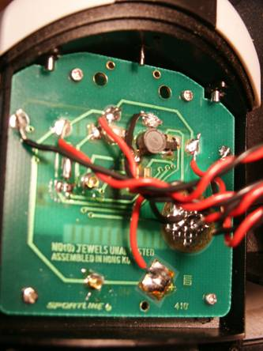
Inside Stopwatch
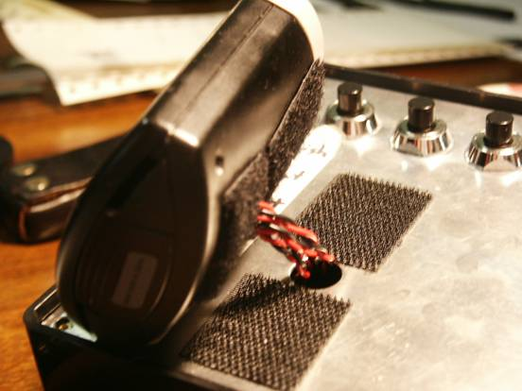
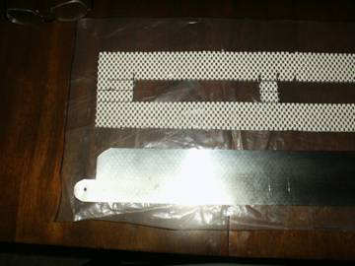
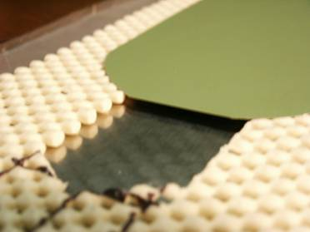
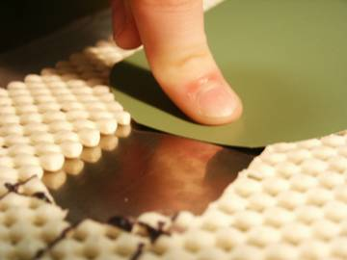
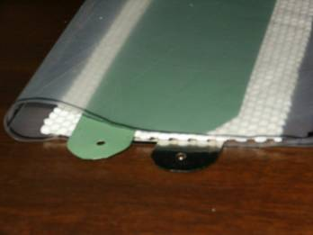
Tape Switch
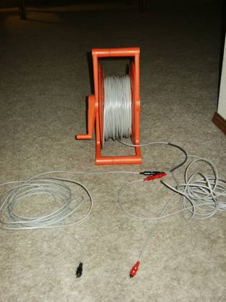
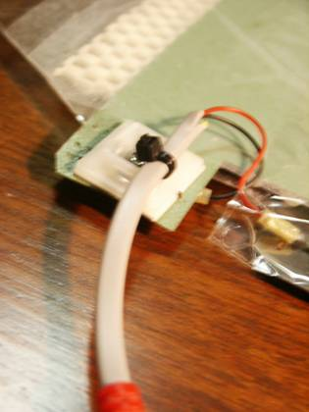
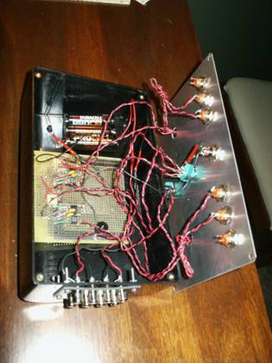
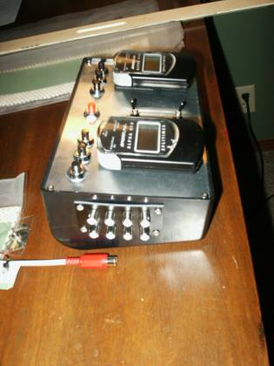
Timing Box

